**Narrative report Frans’ hike in The Netherlands, 7-12th April, 2017.**

**Introduction**

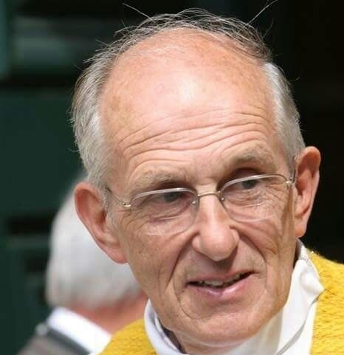

***“At the end of every hike… We notice that there is no one not loved”. (Father Frans van der Lugt JS)***

***At the end of this hike we all deeply felt loved!***

In this narrative report we, the organisers of Frans’ Hike, would like to share with you the success of the hike in The Netherlands. We would like to take the opportunity to thank you for your kind and generous support and your trust in our mission. We also would like to stress that we owe a great deal of gratitude to all the people who helped us along the road: the organisations which hosted the 180 participants for the night, the municipalities along the track of the hike for their approvals, the kitchen facility in the Jeugdhuis in Beugen and all the individuals who supported us in many ways.

**Let’s remember who started the hikes in Syria?**

Fr. Frans was a Jesuit priest. He lived in Syria for 40 years. During his stay in Syria he initiated many activities, one of them was the hike “Al Masseer”, which started in Syria in the beginning of the 80’s and aimed to raise social and environmental awareness. The hike gathered Syrian people from all the different religions, ages and regions. And many Europeans and people from other parts of the world joined.

Fr. Frans’s ministry in Syria changed the lives of many people by introducing them to a new way of life. For many, their experiences with him were vital in becoming who they are now. Through Frans’ hike in Syria they found a way to truly integrate with their own people. Fr. Frans remained faithful to the Syrian people, whom he loved deeply, right up to his assassination in the Jesuit convent in Homs in 2014.

**Keeping Father Frans’ legacy alive**

The activities and hikes of Fr. Frans also inspired Syrians who have left Syria because of the war. On 7 April, 2015, one year after Fr. Frans’ assassination,

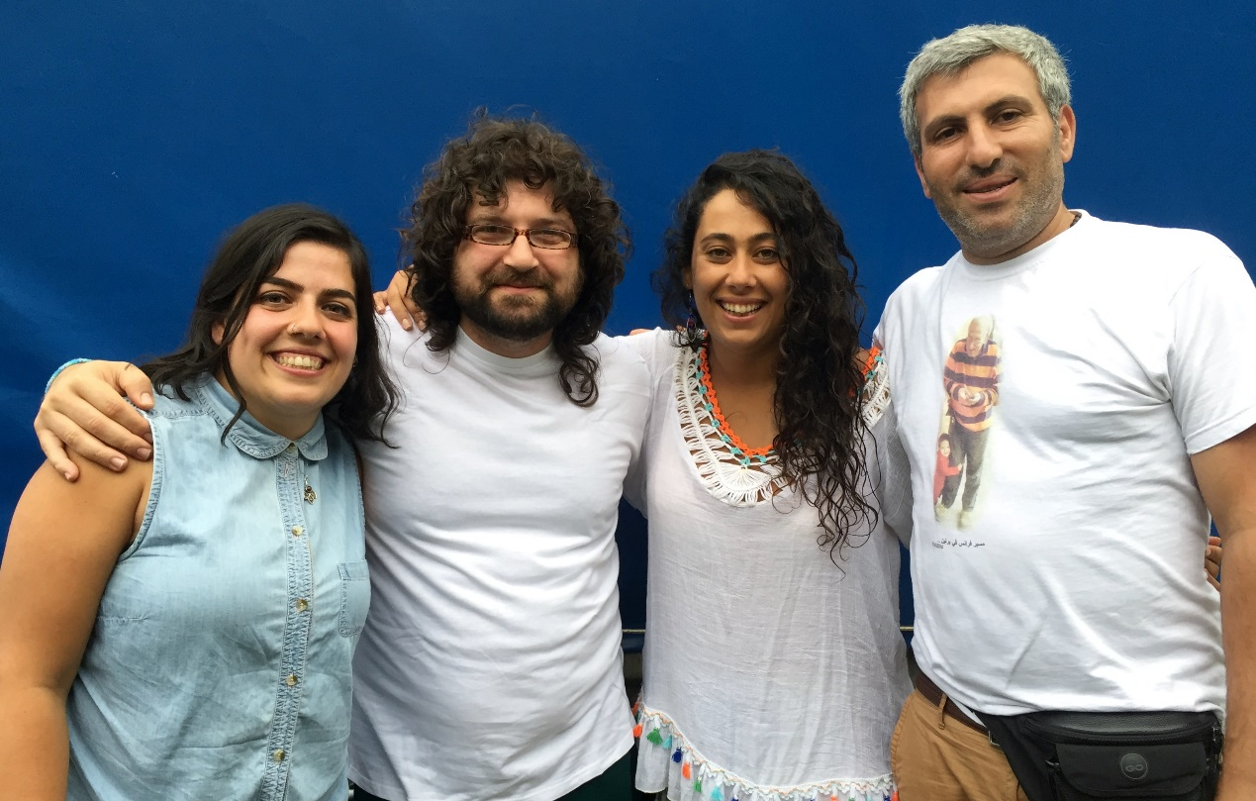

Rasha Youssef, Rabee Khuzam, Magui Al Ahmar, and Issa Kardouh established the Frans’ hike hiking group to continue his initiative and to pass on what they learned from him to people in other countries***“Father frans gave us his life ..We had to give something back”***. The hike is an activity that is beyond politics and religion and it is open to people of all religions, nationalities and ages. Thus, different cultures and nationalities enrich the hike and contribute to breaking down prejudices.

The team has organized six hikes in different regions in Germany since then. These hikes attracted a wide variety of people, mainly young Syrian women and men who came to Europe escaping the war in Syria.

Because of Fr. Frans’ Dutch roots, we decided to organise a hike in The Netherlands in 2017 and preparations started in autumn 2016. Eventually this hike was supported financially and/or in kind by:

* the Jesuits Netherlands, Germany and Belgium,
* the Vereniging Nederlandse Bedevaarten (VNB) 
* PAX Netherlands, 
* Lutfia Rabbani Foundation, 
* Iona Foundation, 
* Renate Foundation,
* Retour Scouting Overloon 
* And a team of Dutch and Syrian volunteers.

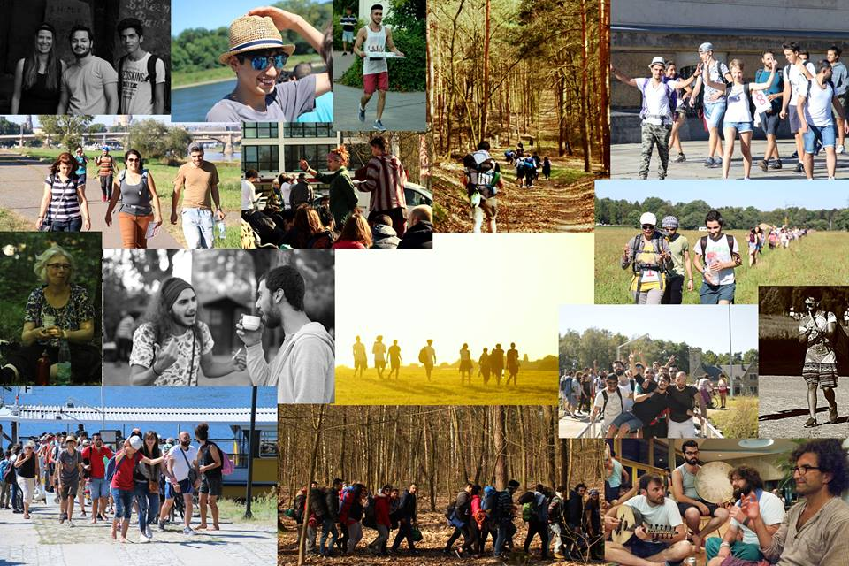

**Frans’ Hike Day by Day**

**7th April Den Bosch**

Since the morning participants started to gather on the square in front of St Jan Cathedral in Den Bosch. Registration was done in the afternoon in the seminary and 170 people registered for the walk. The hike started with a memorial service at 5.30 pm in the St Jan Cathedral in Den Bosch. The memorial service was well attended by well over 250 people. After a welcome by Bishop Herard de Korte, Fr. Jan Peters SJ led the service in which Fr. Frido Pfluger SJ from Germany and Fr. Jan Stuyt from Belgium participated as well. Testimonies where shared by people who had known Frans for decades and by people who had not known him personally but who through the hikes had gotten to know him ‘post mortem’. They all shared the positive influence he has on their lives.

After the service the group met on the square in front of the cathedral and a photo was taken with frans’ family and everyone who attended the mass. The group then was transported by buses to the retreat centre Emmaus for the overnight stay. There was some confusion because the bedrooms allocated didn’t offer enough space for all the participants. Finally the caretaker opened some more rooms on the second floor to accommodate all.

Learning points:

* Four long testimonies made the service very long, maybe next time reducing the number or length (less is more) of the contributions should be considered;
* More clarity was needed about the sleeping facilities. Because of the confusion it took a long time for some to find a sleeping place and it caused some –unnecessary- tensions.

**8th April Walk from Helvoirt to Heeswijk (29 km)**

Breakfast was provided by the centre. Early in the morning people started to sing and dance outside which helped to create a very positive atmosphere. The group was divided in smaller groups of 11 participants. It was a lovely warm day and people in their gardens greeted the group with kindness and interest. Along the way passers-by asked about the hike and showed a very positive interest. Lunch was a picnic in the woodlands. Each group of eleven received a lunchbox. The boxes had been prepared by volunteers in the kitchen facility in Beugen. It was a good way of connecting with other people of the group. Upon arrival at the sports complex in Heeswijk there were a few concerns about safety and the need to make sure nobody would enter the sports hall with shoes on. Very quickly a team of supervisors was formed and the whole group was very collaborative. Dinner was served in the school yard and in the evening there was a meeting in the cantine of the local school located in the same complex. There was a very peaceful atmosphere and the overnight went very well.

**9th April Walk from Heeswijk to St. Agatha (38 km)**

On an even warmer day we walked (with some exceptions) the long distance from Heeswijk to St. Agatha. Up until lunchtime the walk went very smoothly. We had a long lunchbreak during which some were still not too tired and enjoyed dancing and singing Syrian folk songs. A young girl carried her violin all the way. Some participants followed Fr. Frans’ advice to carry their own luggage and didn’t send it with the van that was available for transport. After lunch tiredness set in and some (sometimes due to not very good footwear, blisters and inexperience) said that they were unable to carry on. Different people with cars started to pick people up and took them to St. Agatha. It started to get dark and still we hadn’t arrived at the destination. Local residents (the mayor included!) set up a shuttle service picking up walkers in the dark and bringing them safely to their destination, where they were welcomed by other participants. It didn’t matter if you arrived by car or on foot everyone got the same cheer. Although people got very tired (and sometimes even quite grumpy) the long hike helped to bond, to support one another and connect on a level that wouldn’t have happened during an easy stroll. Of course the participants were welcomed to a nice dinner prepared by the cooking team in Beugen.

Learning points

* Accurate information needs to be given to participants about the length of the walks and footwear;
* A better time schedule is needed for long walks (shorter breaks);
* Review the distance, one that is manageable for the group.

**10th April Group sharing, workshops and celebration of Fr. Frans’ birthday**

After breakfast and the usual cleaning activities, all enjoyed a welcome day of rest in the beautiful environment of St Agatha. In the morning sharing in small groups and the big group took place. Participants shared their dreams but also their experience of the walk.

**Testimony**:

Lina from Homs: ‘*I had the privilege to grow up near father Frans in Homs, and I learned a lot from him throughout my life. When father Frans died I was so depressed, and I thought to myself that future generation had completely lost the chance to have their lives changed via Frans ministry ……. But now after I join the hike I would like to say that future generation haven’t lost the chance because by ding the hike you kept father Frans alive*’

In the afternoon several workshops were organised. The 5 workshops planned well in advance were:

* Why vegan? By Marloes luisa
* Introduction in ‘The work’ as developed : by Bryon Katie
* Gathering songs from around the world by Monique dan de hoogen
* Solidarity and peace making by Pax Christi
* Anger management coping strategies using games by cilia Horst In addition to these workshops some very gifted participants were keen to offer workshops as well. It was fantastic that due to their enthusiasm and without any prior preparation, they delivered the workshops: Meditation and yoga: by kinda kriedi and Shadan alhamwi
* Syrian Folk Music By Marcel Mukdad

The workshops were all very well received. In the evening a local brass band came to play music followed by a bottle of champagne and cake to celebrate Fr. Frans birthday. One of the organisers said we are not just celebrating Fr. Frans’ birthday but the birthday of all of us, because he continues to live in us. More dancing took place and we finished the evening with the dance and song: Salam.

**11th April Walk from St. Agatha to Nijmegen**

A relatively easy walk to Nijmegen. A group decided to walk in silence. There was a lot of coverage by the media. A photographer started to take photo’s without asking permission or making known who he was to the organisers. When we asked he replied that The Netherlands is a free country and he doesn’t need any permission. It was a response that lacked sensitivity and respect. This incident was reported to the newspaper that had contracted him. In contrast the reporter of this newspaper was very perceptive and understanding. The reporter of another newspaper (De Trouw) lived locally and helped a group to find the way, when they got lost. The arrival at the university got a bit lost in the business of students present. It was just another group arriving. However it reminded us that it is not about the arrival but about the journey.

In the evening there was an evaluation and a drink in the university bar. Hope had been raised that there would have been a place and time for final party, but the cafe closed at midnight. A group went to another sports hall but were asked to leave, there was only one sport hall available for the group and most people had already gone to sleep, which didn’t leave much room for people who wanted to continue partying.

Learning points

* Seeking more clarity for the next hikes in which sleeping time and availability of venues.

**12th April Departure from Nijmegen**

People started to leave at different times, but it didn’t stop the rest of the group to dance outside the university and once more join hands to sing and dance Salam. It was a very suitable end of four extraordinary days.

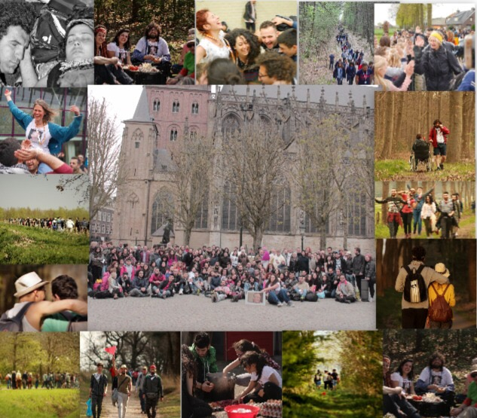

**Media exposure:**

In order to avoid any biased reporting and to guarantee the safety of the participants and their families still in Syria – an aspect often overlooked by reporters - the organisers made Rasha, one of the main organisers, responsible for all media contacts and media coverage. Prior to the start of the hike she maintained contact with several media outlets. During the hike itself, all reporters streamlined their plans with Rasha before they started interviewing or filming. Frans’ Hike looks back at overwhelming positive media attention with for example the 20.00 NOS news broadcast, a two page article in Trouw, radio interviews and coverage in local media.

**Conclusion**

The hike was a success. It brought people together from different faiths, backgrounds and nationalities. The age range was between 7-70 years old.

One participant said: ‘the hike feels like coming home’. Thanks to the help of all the Dutch supporters the local people had been well informed about the hike and this undoubtedly helped the positive attitude of passers-by. The hike helped to create a different and positive image of people who had to flee their home country Syria.

The hike helped participants from Syria, Netherlands, Germany, France, Austria and Sweden to meet, walk, talk, and build bridges, breakdown stereotypes and most importantly to live peace in the time of distraction and war.

During the previous hikes in Germany most logistic matters were taken care of by sponsors and supporters. Even though we got a lot of support by the donors and a team of Dutch volunteers, the hike in The Netherlands got us as organisers much more aware and involved in these organisational and logistical matters. That made this hike for us more complicated and time consuming than foreseen, but on the other hand we learned a lot in terms of organising a future hike in terms of timing of preparations, project proposal writing, budgets, fundraising, permits by local municipalities, safety requirements in general and overnight locations in particular, food logistics and publicity. We are proud that the hike went very smoothly and that no single incident occurred. Uncountable valuable encounters took place among the participants and the passers-by, and the group of participants as a whole developed into a a group of people taking care of each other and reaching out to each other. It was for example very moving to see how a group of youngsters who separated themselves from the group at the start of the hike slowly began to connect more with the wider group and open up. As Fr. Frans would say: ‘*“At the end of every hike… We notice that there is no one not loved”.* This was surely the case during this hike.

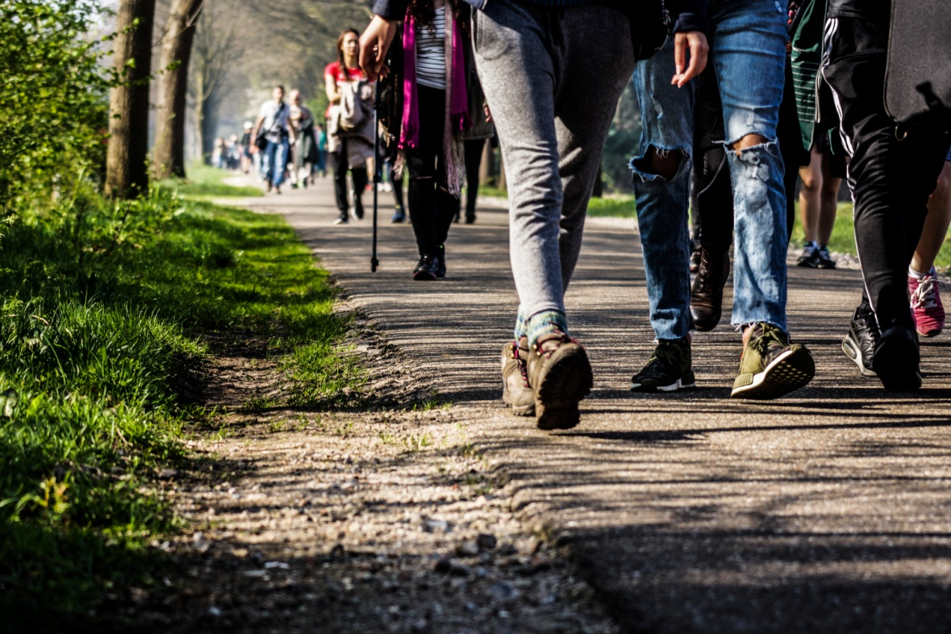

Frans hike April 2017 by Anas Sroji

Please check frans hike out:

Website: <https://franshike.wordpress.com/>

Facebook: <https://www.facebook.com/profile.php?id=100011179997659>

Frans’ hike in the Netherlands by PAX: <https://youtu.be/bRh38XJDLbY>

Frans’ hike in the Netherlands by katholiekleven.nl: <https://youtu.be/kUSzntUEZ2E>